**Afraid Of The Dark**

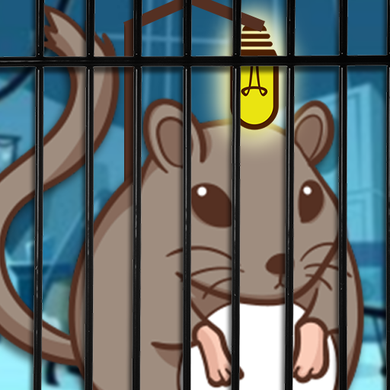

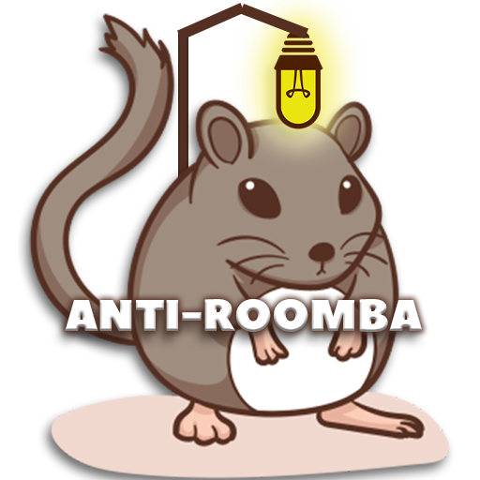

**Company: Anti-Roomba**

**Developers: Jolanne Manalese, Robert Day, Terry Tse Pak Lueng**

* **Game Name:** Afraid of The Dark
* **Genre:** Afraid of the Dark is a 3D mobile puzzle game
* **Game Platform:** Mobile
* **Target Audience:** 10+, Afraid of the Dark is a 3D mobile puzzle game
* **Game Overview**
  + **Game Concept:** You’re the last lab rat survivor called “Jahseh” with a debilitating fear of the dark. Equipped with a faulty light unit strapped to you back that is constantly running out of power, you have to navigate a dark labyrinth of traps and evil robots. You must find the path out of the maze while keeping an eye out for batteries and cheese to make sure your backpack stays charged up and you stay alive.
* **Gameplay and Mechanics**
  + **Objective:** Course through the maze and try not to die from your fear of the darkness.
  + **Game rules:** Avoid death from losing health, dying from mouse traps and avoiding the roombots.
  + 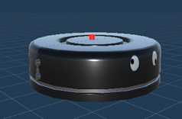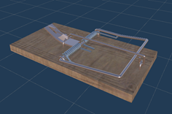
  + The player uses physics to move by pressing arrow buttons on the HUD.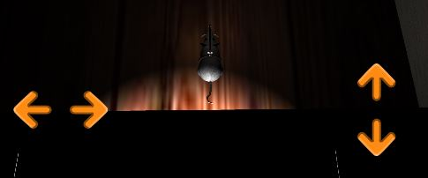The AI Roomba robots use NavMesh to travel between waypoints.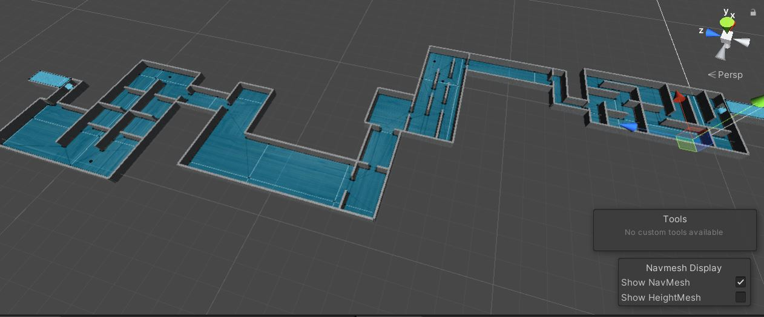
* **Interface**

***Start Game UI***

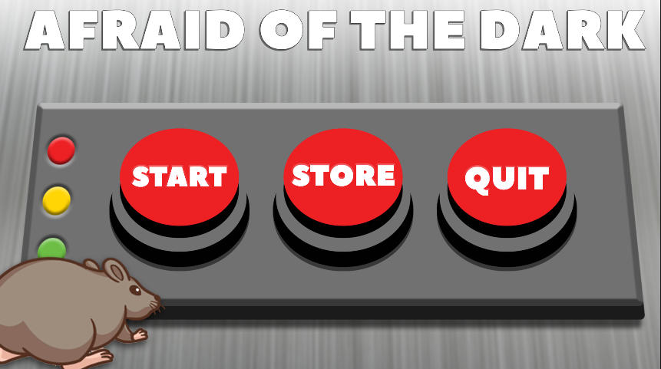

* Start: Starts the game
* Store: Opens IAP menu
* Quit: Closes application

***IAP Purchase Menu***

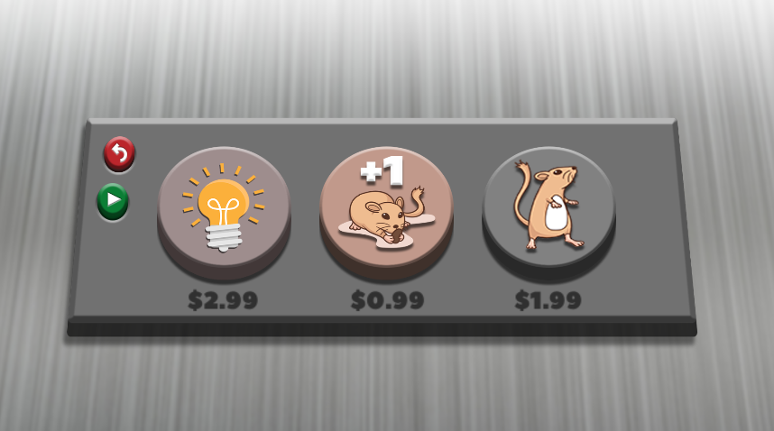

**All catalogued items are non-consumables**

* Extra brightness: Give you double the light intensity forever
* Enhancement Vaccine: Doubles your health forever
* Speedy Gonzales: Doubles your speed forever

***Advertisement UI Menu***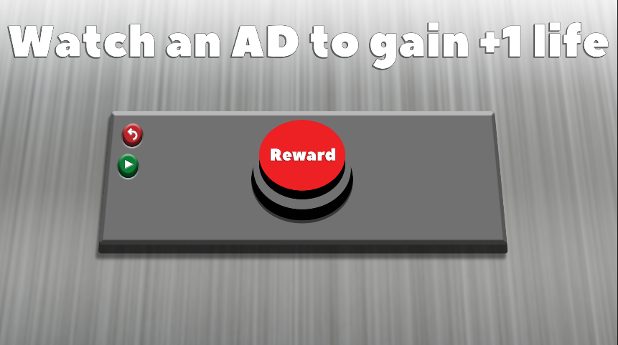

* Asks the player if they want to watch the video for an extra life when pressed.

***Confirmation Menu***

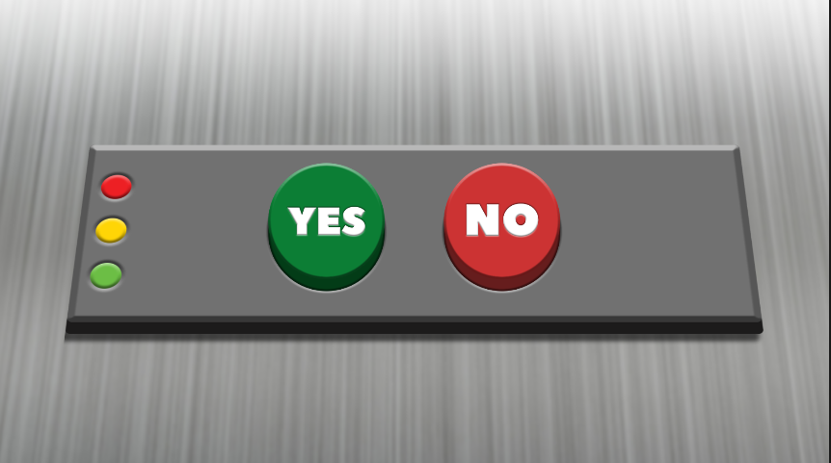

* Directs the player to the ad if “Yes” and “No” will bring the game over canvas.

***In-Game Pause Menu***

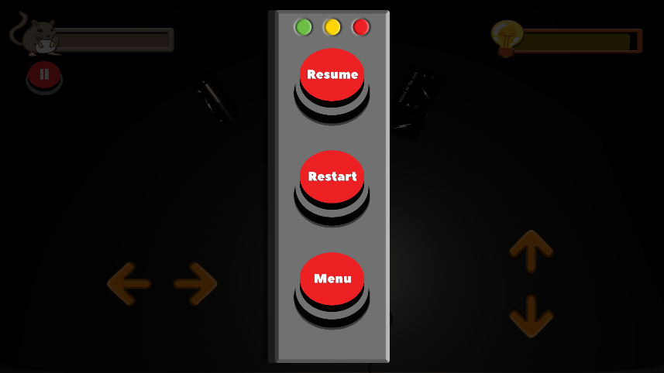

* Resume: Resumes the game after pausing.
* Restart: Restarts the level.
* Menu: Brings you back to the main menu.

***Mouse Model***

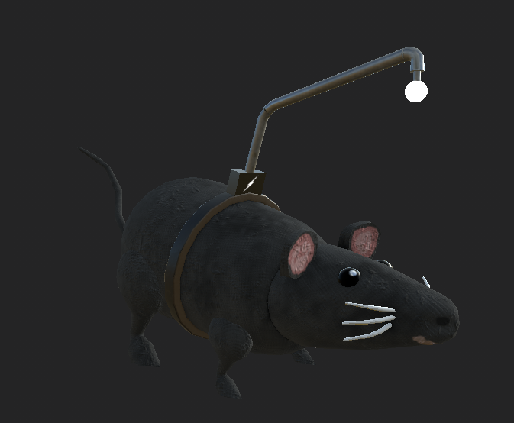

* The last rat lab survivor named Jahseh.
* **Sounds**
  + **Background Music:** Lab ambience on loop
  + **SFX** includes pickup items, player movements, buttons, mouse traps and roombots
* **Win and Lose Condition:**

· Win: You reach the light tunnel.

· Lose: If you die 3 times from the roombots, rat traps and/or of FEAR.

* **Pickups**

***Small Battery, Big Battery and Cheese***

